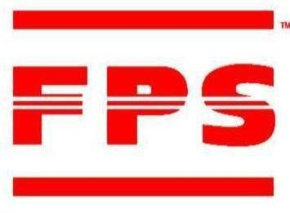

Famous Pacific Shipping (VIC) Pty *World Famous For Our Tailor-Made Logistics Solutions*
Offices Worldwide

LCL SAILING SCHEDULE MAY 2026

SINGAPORE & SOUTH EAST ASIA PORTS
Vessel & Voyage No. | SYD | MEL | ETD | ETA
 | Cut Off | Cut Off | MEL | Singapore | Bangkok | Jakarta | Ho Chi Minh | Manila | Busan
MAERSK SHEKOU v. 619N | 5-May | 7-May | 9-May | 8-Jun | 16-Jun | 16-Jun | 16-Jun | 20-Jun | 25-Jun
CMA CGM TIGRIS v. 620N | 12-May | 14-May | 15-May | 16-Jun | 24-Jun | 24-Jun | 24-Jun | 28-Jun | 3-Jul
MAERSK SEMAKAU v. 621N | 19-May | 21-May | 23-May | 22-Jun | 30-Jun | 30-Jun | 30-Jun | 4-Jul | 9-Jul
WESTPORT v. 622N | 26-May | 28-May | 29-May | 30-Jun | 8-Jul | 8-Jul | 8-Jul | 12-Jul | 17-Jul
KOTA LARIS V.040N | 2-Jun | 4-Jun | 5-Jun | 6-Jul | 14-Jul | 14-Jul | 14-Jul | 18-Jul | 23-Jul

HONG KONG
Vessel & Voyage No. | SYD | MEL | ETD |  | ETA
Vessel & Voyage No. |  |  |  | Hong
Vessel & Voyage No. | Cut Off | Cut Off | MEL | Kong | Shanghai | Xingang
KOTA LARIS v. 098N | 29-Apr | 1-May | 7-May | 14-Jun | 23-Jun | 3-Jul
OOCL HOUSTON v. 217N | 6-May | 8-May | 13-May | 16-Jun | 25-Jun | 5-Jul
KOTA LUMAYAN v. 189N | 13-May | 15-May | 19-May | 28-Jun | 7-Jul | 17-Jul
OOCL BRISBANE v. 249N | 23-Dec | 22-May | 26-May | 28-Jun | 7-Jul | 17-Jul
KOTA LARIS v. 099N | 3-Jun | 5-Jun | 10-Jun | 12-Jul | 21-Jul | 31-Jul

For all bookings please email exports@fpsaus.com.auor call our friendly export team on 03 83660700

LCL CARGO RECEIVAL DEPOT FPS BOND STORE
170 AUSTRALIS DRIVE, DERRIMUT, VIC 3030 FPS EXPORT STACK
Receivals between 7.30am to 4.00pm (Monday – Friday) (Licence Number:016796B / Est. Code: FX40K)
AQIS QAP License #V1771 / DAIRY ESTABLISHMENT #153

