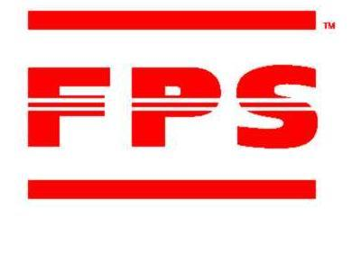
Famous Pacific Shipping (VIC) Pty
*World Famous For Our Tailor-Made Logistics Solutions*
Offices Worldwide



LCL SAILING SCHEDULE
JULY 2025

SINGAPORE & SOUTH EAST ASIA PORTS
Vessel & Voyage No. |  | SYD |  | MEL |  | ETD | ETA
 |  | Cut Off |  | Cut Off |  | MEL | Singapore | Bangkok |  | Jakarta | Ho Chi Minh | Manila | Busan
SYDNEY EXPRESS V. 527N |  | 29-Jun |  | 1-Jul |  | 7-Jul | 4-Aug | 12-Aug |  | 12-Aug | 12-Aug | 16-Aug | 21-Aug
MAERSK SHEKOU V. 528N |  | 7-Jul |  | 9-Jul |  | 14-Jul | 11-Aug | 19-Aug |  | 19-Aug | 19-Aug | 23-Aug | 28-Aug
MSC TOKYO V. ONNLCW1NL |  | 15-Jul |  | 17-Jul |  | 24-Jul | 9-Aug | 17-Aug |  | 17-Aug | 17-Aug | 21-Aug | 26-Aug
MAERSK SEMAKAU V. 530N |  | 19-Jul |  | 21-Jul |  | 26-Jul | 25-Aug | 2-Sep |  | 2-Sep | 2-Sep | 6-Sep | 11-Sep
WESTPORT V. 531N |  | 23-Jul |  | 25-Jul |  | 1-Aug | 1-Sep | 9-Sep |  | 9-Sep | 9-Sep | 13-Sep | 18-Sep

HONG KONG
Vessel & Voyage No. | SYD | MEL | ETD |  | ETA
Vessel & Voyage No. | Cut Off | Cut Off | MEL | Hong Kong | Shanghai | Xingang
KOTA LARIS V. 0090N | 2-Jul | 4-Jul | 8-Jul | 10-Aug | 19-Aug | 29-Aug
OOCL HOUSTON V. 0209N | 9-Jul | 11-Jul | 16-Jul | 17-Aug | 26-Aug | 5-Sep
COSCO SINGAPORE V. 0191N | 13-Jul | 15-Jul | 20-Jul | 14-Aug | 23-Aug | 2-Sep
KOTA LUMAYAN V. 0181N | 15-Jul | 17-Jul | 22-Jul | 24-Aug | 2-Sep | 12-Sep
OOCL BRISBANE V. 0241N | 22-Jul | 24-Jul | 29-Jul | 7-Sep | 16-Sep | 26-Sep

For all bookings please email exports@fpsaus.com.au or call our friendly export team on 03 83660700
LCL CARGO RECEIVAL DEPOT

FPS BOND STORE
170 AUSTRALIS DRIVE, DERRIMUT, VIC 3030

FPS EXPORT STACK
Receivals between 7.30am to 4.00pm (Monday – Friday)
(Licence Number: 016796B / Est. Code: FX40K)
AQIS QAP License #V1771 / DAIRY ESTABLISHMENT #153

